# **Laboratory practice No. 1: Recursion**

|  |  |
| --- | --- |
| **Andrés Echeverri Jaramillo**  Universidad Eafit  Medellín, Colombia  aecheverrj@gmail.com | **Juan Sebastian Jacome Burbano** Universidad Eafit  Medellín, Colombia  jsjacomeb@eafit.edu.co |

**3) Practice for final project defense presentation**

*The next image is the graph taken in point one, with the measures from 2 to 40*

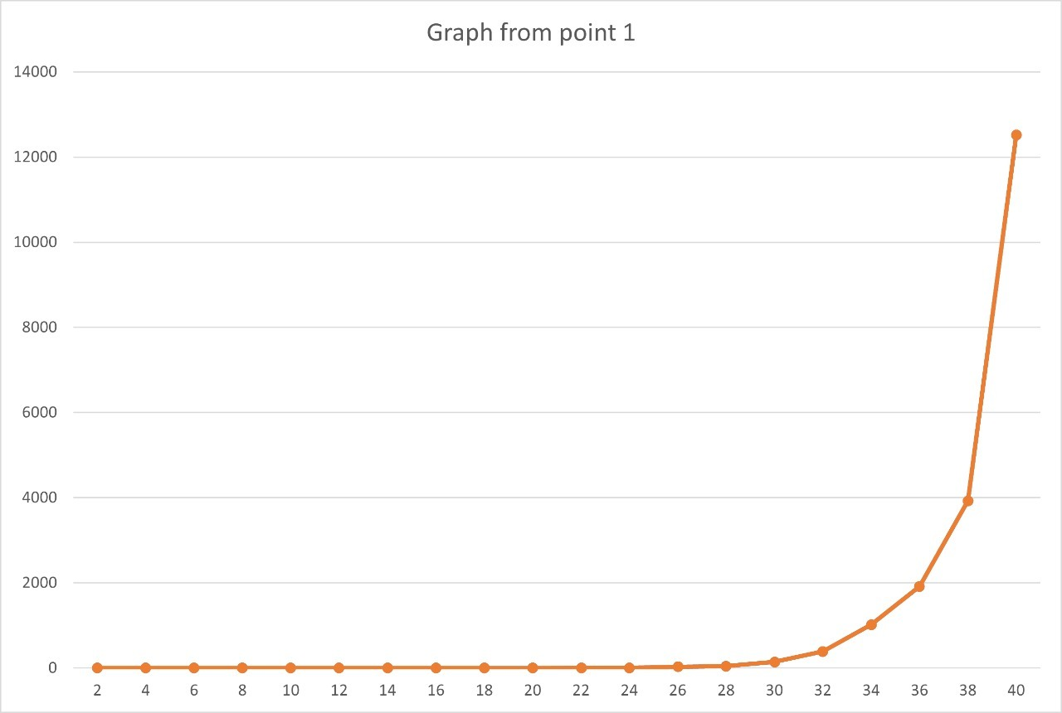

Keep in mind that the x-axis is the amount of numbers used and y-axis is the time in milliseconds

**3.1** 2^n

**3.2** It can’t be estimated since with the amount of data they give, it would not give a measurable number by java or similar programs.

**3.3** No, because the amount of the would saturate the program and java wouldn’t processes it, so it impossible.

* 2. **2.1.1** T(n)= cn+c_1

**2.1.2** T(n)= cn+c_1

**2.1.3** T(n)= cn+c_1

**2.1.4** T(n)= cn+c_1

**2.2.1**

**The rest of recursion 2 I will upload them in a separate document (qualifiable or not) since in the class we haven’t learned to calculate the complexity with the for**

**3.6** Nis the amount of the data that is given.

**4) Practice for midterms**

* 1. 1) c. s.substring(i, n), this decision was made due to the code not having recursion in the specified line, thus, we need two established variables that can continuously tell us which substring we are choosing.

2) c. true, this decision was made by process of elimination (somewhat), this is because the other options were either not compatible with the type of value the return had to give, or would make the if have no purpose.

2) c. solve.(t, substring(n), I-n), this decision was made because it was the most accurate one in our eyes.

* 1. 1) a. True, this decision was made as logarithms cannot give a negative number as an answer

2) (A) True, as this goes accord with the principles of functions

(B) True, as a logarithm cannot poses a negative number as a base

(C) False, as O=(log(n))

(D) Uhhhhh, What…?

* 1. D. T(n,m)=C x n x m^3, this decision was made because when calculating the complexity of each line in the code, the highest power the m got was 3.
  2. C. Because that is the formula for the Lucas´ numbers
  3. 1) a. True because this makes a string that has 0 or 1 characters return true, which is correct, as a word of 0 or 1 letters is a palindrome in and of itself.

1. b. s.charAt(0)==(s.charAt(s.length()-1)), this line of code compares the first and the last character of the string, which is what the code is intended to do,
2. a. T(n)=T(n-1)+c this is because this is the complexity formula for recursive codes, also, b and c just don´t make sense in a recursive standpoint
   1. 1) return sumaAux(n.substring(i+2), i); this is because this is the thing that the if checks, if the 2 adjacent numbers are the same, do not use them in the final sum, therefore if charAt(i)==charAt(i+1), the two numbers that are the same are skipped, and the string given afterward is the remainder of the number after that

2) (sumaAux,charAt(i+1), i); this returns the number at a certain spot in the string, turning it into an int, and using it for the final sum

**5) Recommended reading (optional)**

Mapa conceptual

**6)** **Team work and gradual progress (optional)**

* 1. Started Saturday 5:00 p.m to 8:00 p.m (Finished points 1.1 and 1.2)

Continued Sunday 12:00 p.m to 10:30 p.m (Attempted to work point 3, to no avail. Finished most of point 2)

Finished Monday 4:00pm to pm (Finished points 3 and 4)

* 1. Saturday: Began and finished the codes for points 1.1 and 1.2

Sunday: Began and made significant process in points 2.1 and 2.2

Monday: Finished the remainder of point 2.2

***6.3*** From what I understand, this is just mentioning the things that were mentioned in the points 6.2 and 6.3